Order your student a Switlik Logo Chromebook Case

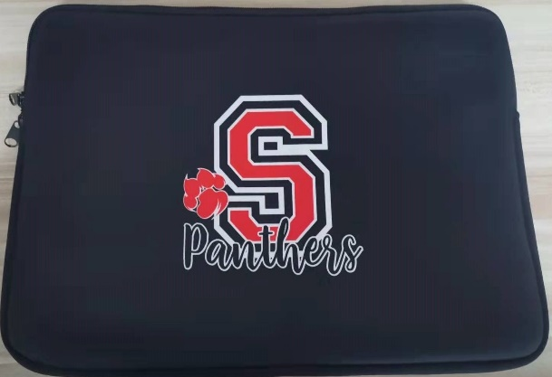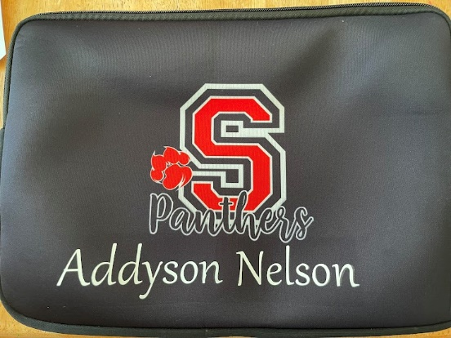

Cases will be delivered to SWITLIK and distributed by classroom teacher

 |  | Yearbook | Qty | Price | Amount Due
Student’s Name: |  | Regular Price |  | $15
Grade:
Teacher:
Parent’s Email: |  | Name Printed on Cover |  | $5
Phone #: |  | Total
Please return with cash or check made payable  to “Switlik PTN” to your child’s teacher. Include telephone #, child’s name, & teacher’s name on the check. If paying with Venmo (@Switlik-PTN) please include student name/teacher name in comments. |  | If “Name Printed on Cover” is selected, please print the  name how it should appear on the cover.
 |  | To be completed by PTN Staff:
 |  | Date Received Amount Received
 |  | - Cash ☐ Check Check #

